BLE Beacon

Power Consumption Overview and Optimization

Andreas Erdmann

[Kurstitel]

Inhalt

2 Baseline 10

3 The baseline for the device is measured with only the Softdevice and no app flashed. 10

4 According to Specification 10

5 Nrf52 according to spec TDB 10

6 **Device KX022** high power mode 145 uA@2.5V low power mode 10 uA standby 0.9 uA 10

7 **Device SHT3** idle state 0.2 uA (max 2 uA) Average 2 uA while measuring w/lowest repeat.+single shot) 10

8 Case 1: Softdevice flashed, no app flashed 11

9 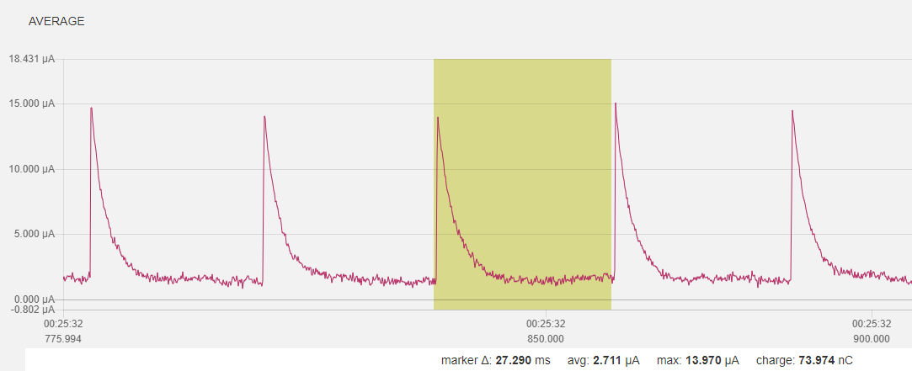 11

10 Case 2: Softdevice, just go to idle mode 11

11 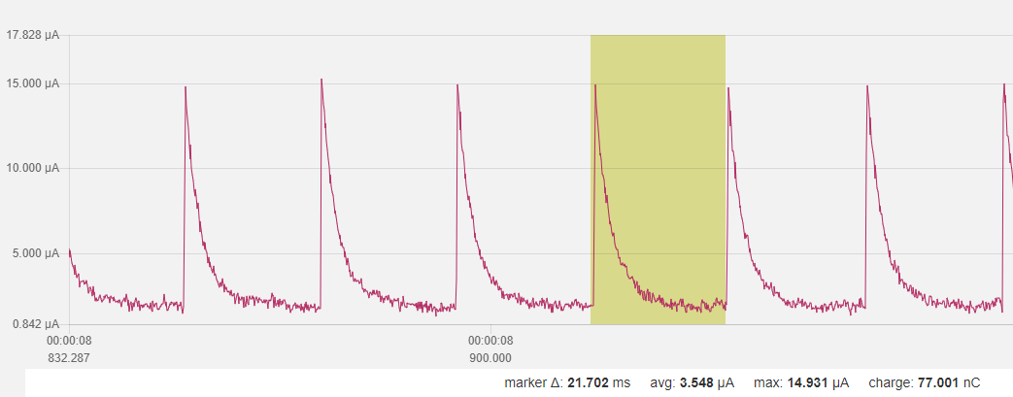 11

12 Case 3: Softdevice, init bsp (led off), and just go to idle mode 11

13 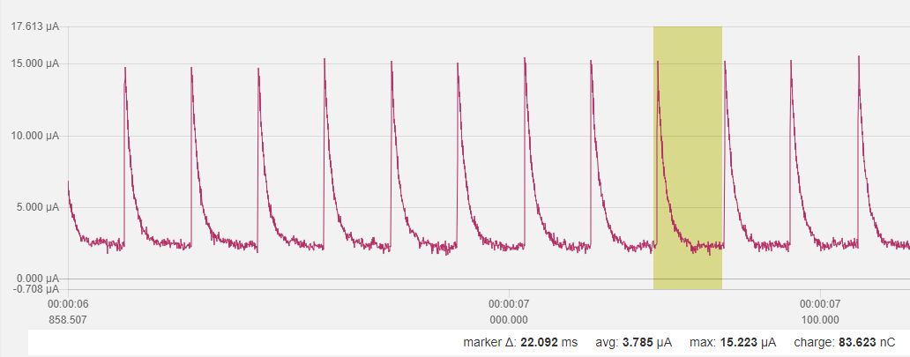 11

14 Case 3b: as case 3 w/one led on 11

15 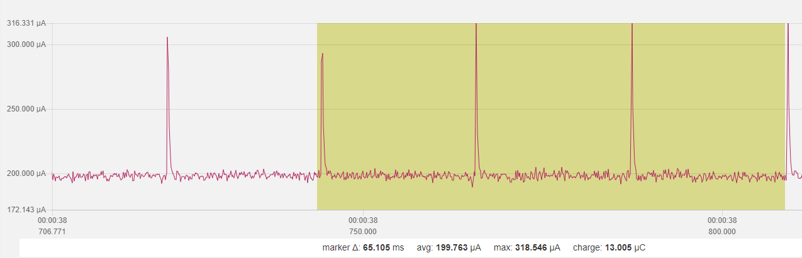 12

16 Case 4: as case 3 (led off) + twi_config + (both) sensor_init 12

17 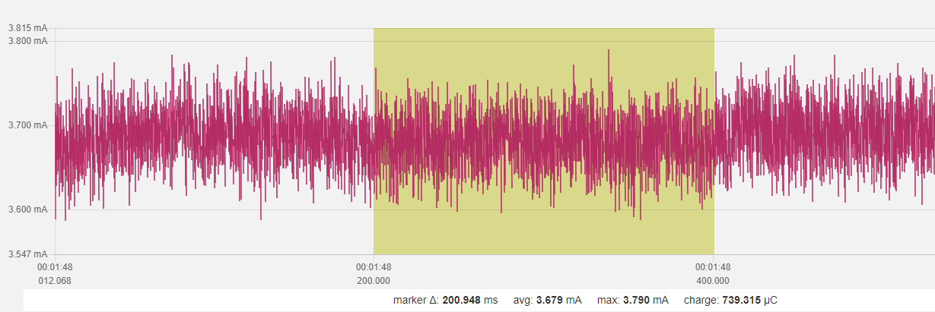 12

18 Case 4a: as case 4 but no sensor_init 12

19 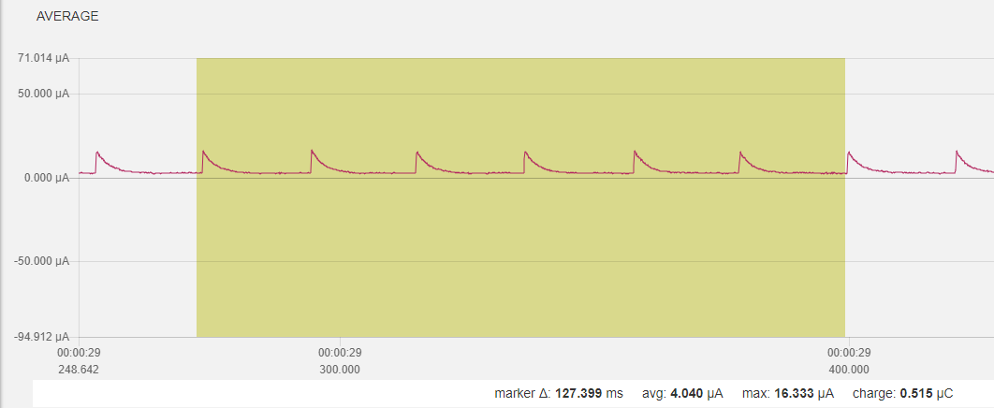 12

20 Case 4b: only kx022 init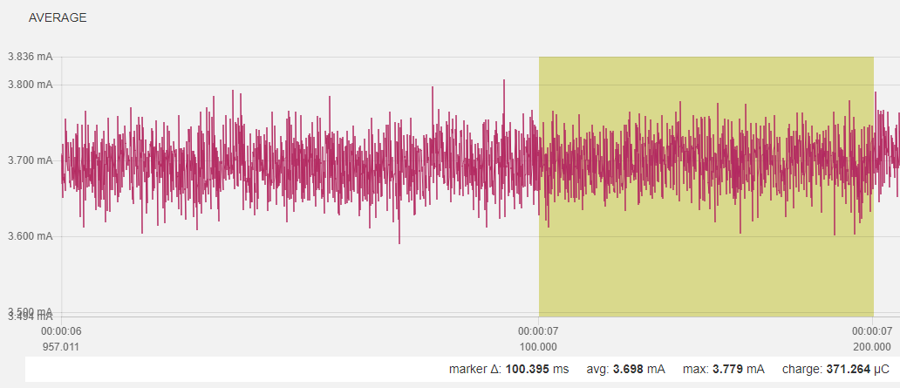 13

21 Case 4c: only SHT3 init 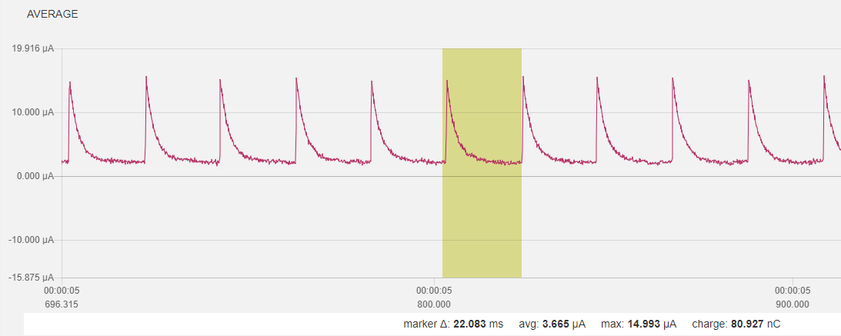 13

22 Case 5: as case 4c/SHT but no KX022, no sensor data + BLE adv 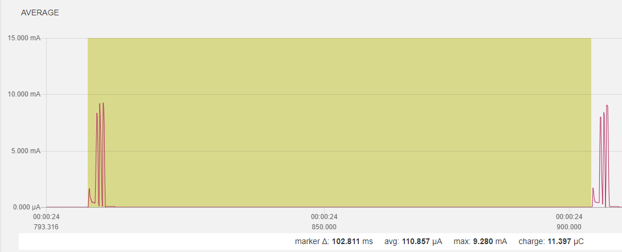 13

23 Case 6: as case 5+ SAADC measurement)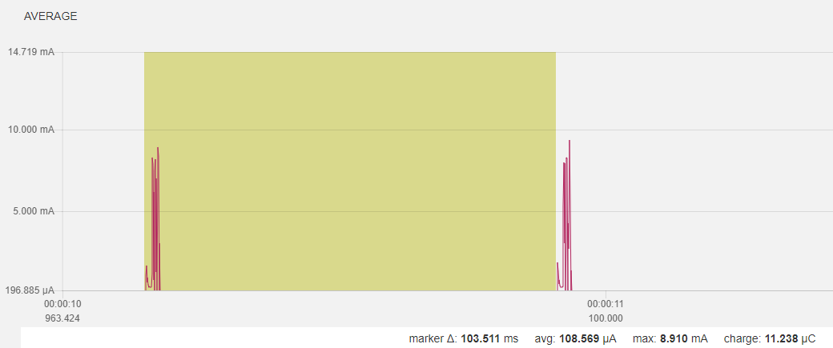 14

24 Case 6a: as case 6 w/o BLE init/adv 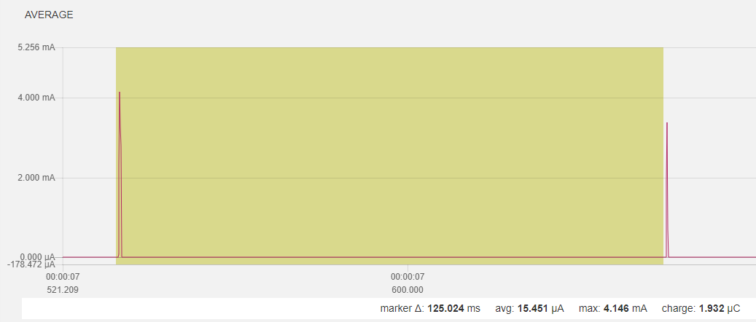 14

25 Case 7: as case 5 + SHT measurement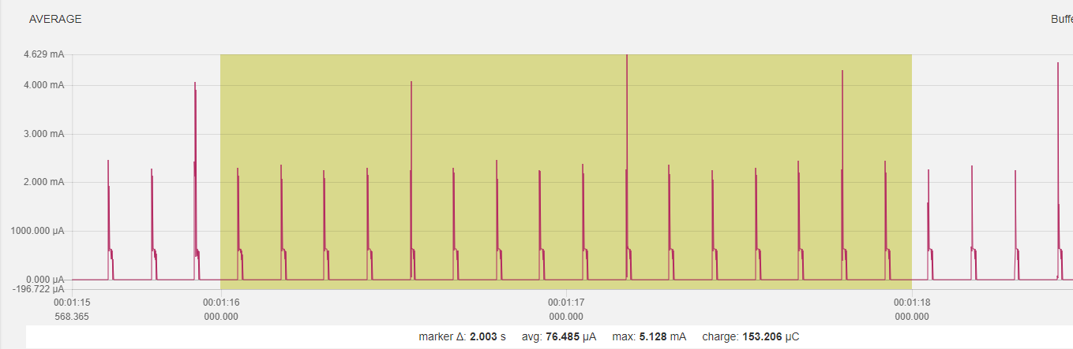 14

26 Case 8: all but KX022 measurement, 1/8 data acquisition for SHT and SAADC 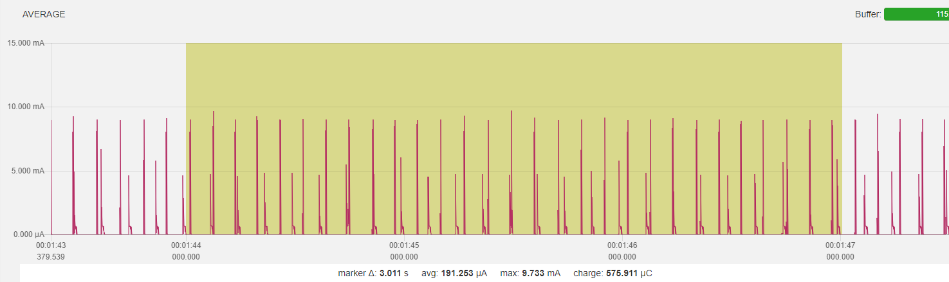 15

27 Case 8a 15

28 reduce transmit power to 0dBm from +4dBm 15

29 adv int to 1 sec from 1/10 sec 15

30 SHT update int to 5 sec from 1/8 sec 15

31 SADC update int to 10 sec from 1/8 sec 15

32 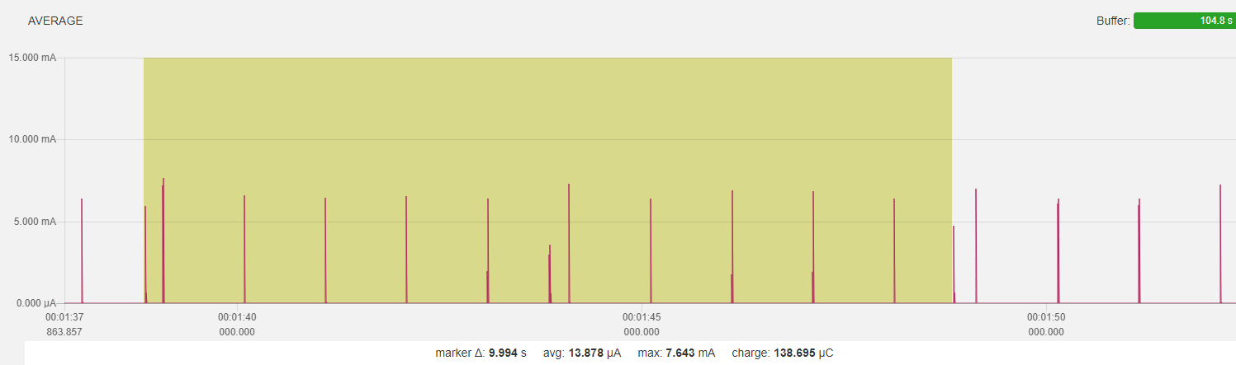 15

33 Sensor update (all 5 sec)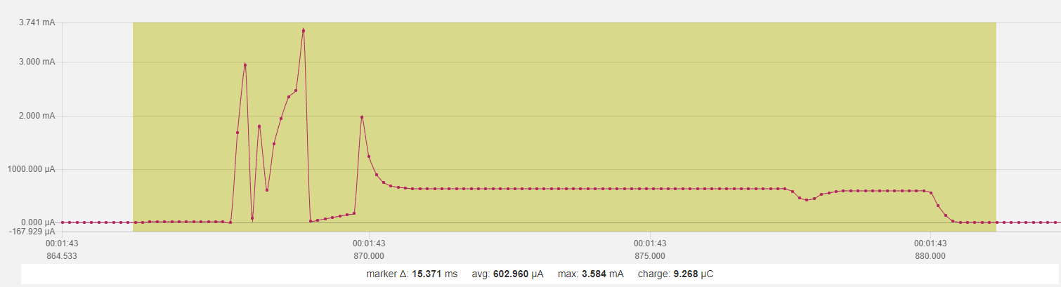 15

34 Adv (all 1 sec)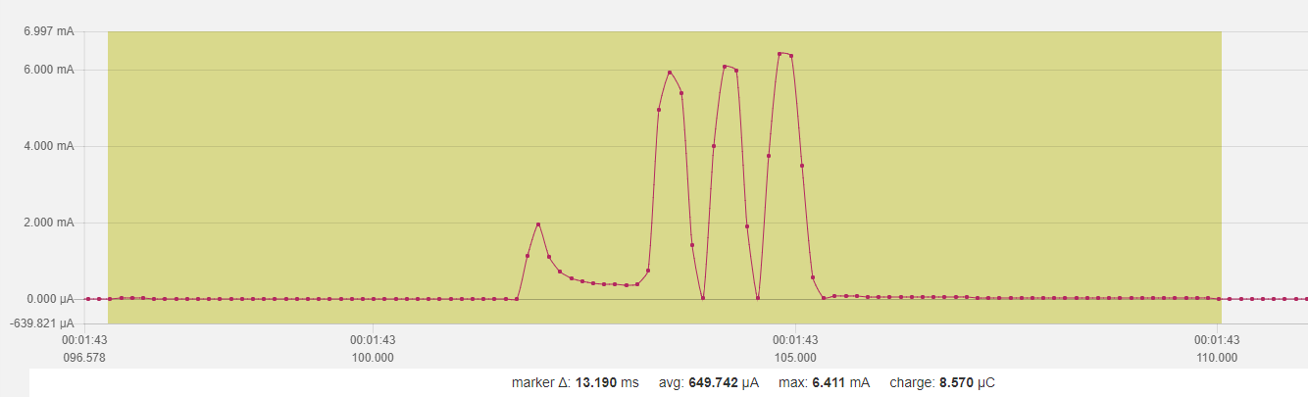 16

35 Startup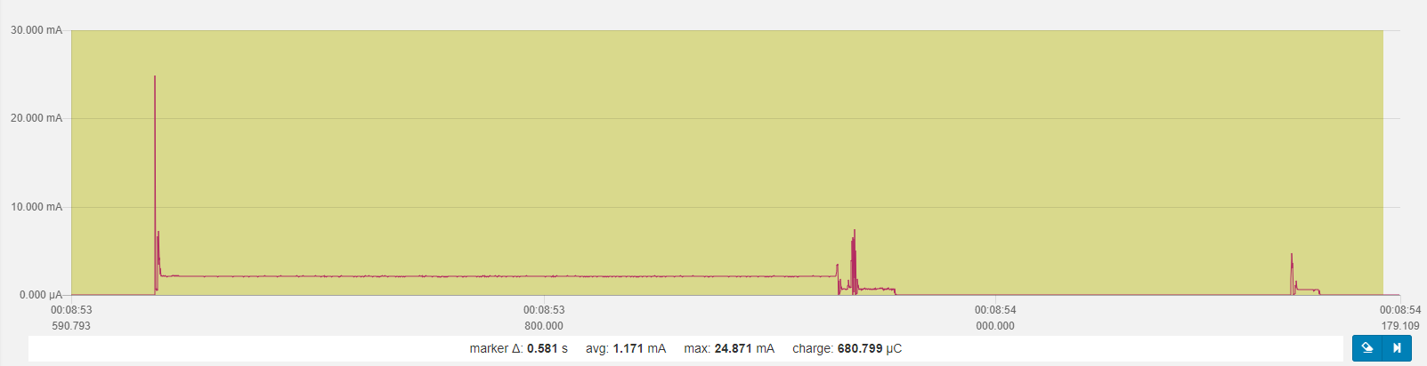 16

36 Peaks 16

36.1 Power on peak 16

36.2 First adv 16

36.3 First sensor acquisition 16

37 Part 2 – Power Optimization KX022 Accelerometer 16

38 Baseline, no BLE, no sensor init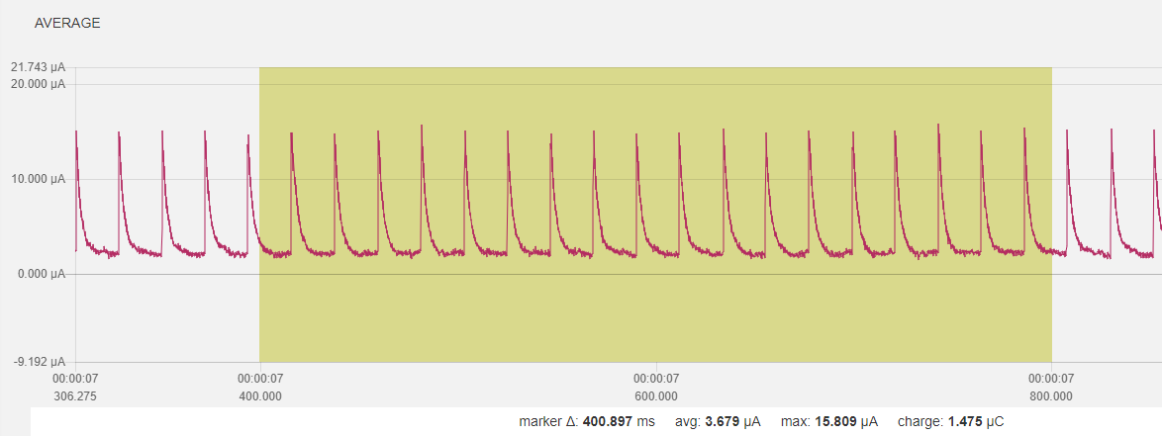 16

39 Change to TWI without transaction manager, SHT3 init and KX022 init to standby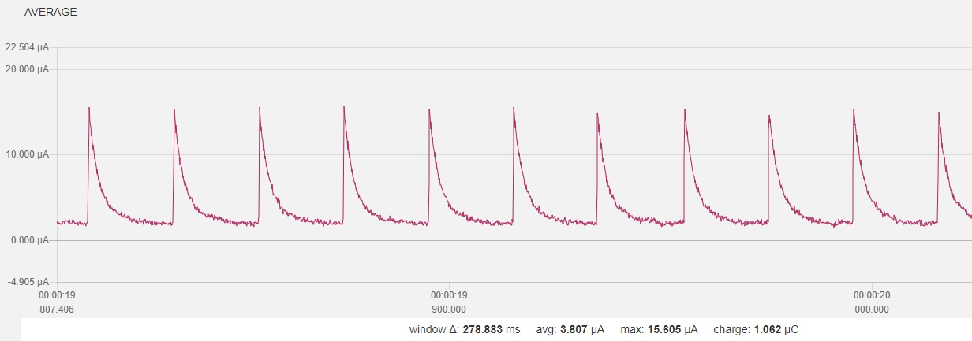 17

40 With KX022 and SHT3 “one shot” measurement, 1 Hz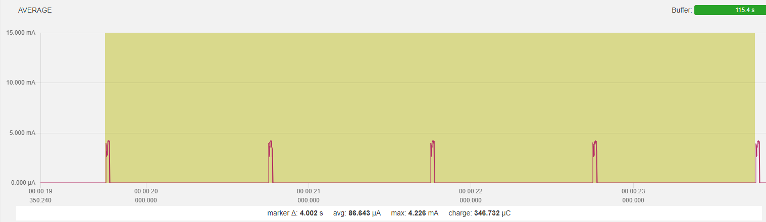 17

41 One measurement 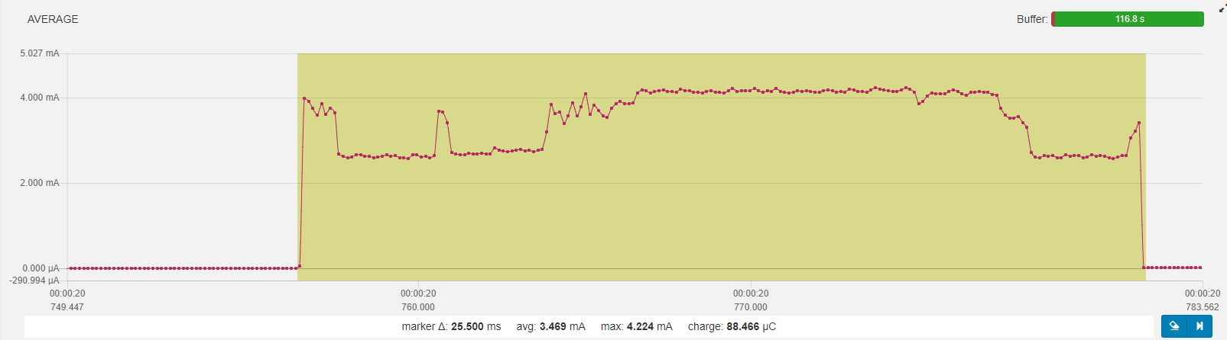 18

42 Init KX022, Standby 1,2ms wait 1.2/ODR 3ms set to operate 0,5ms wait 1.2/ODR for value 3ms read accel values … SUM ~8ms 18

43 Set SHT3 to SHT3_MEAS_HIGHREP_STRETCH wait clock stretch 12,5ms read temperature and humidity 2,8ms SUM ~15ms 18

44 Process data and sleep again… Overall cycle 25ms, avg. power consumption 3,5mA, idle < 4uA 18

45 Overall 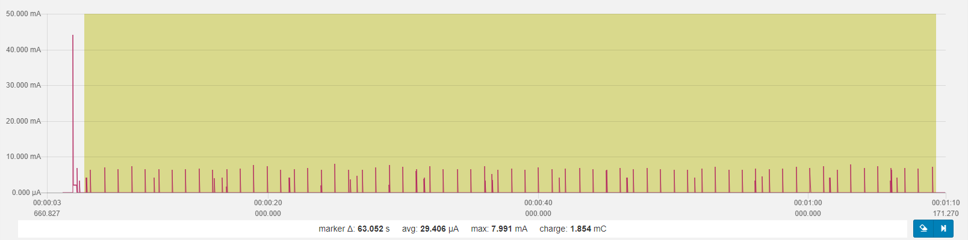 18

46 One 10sec cycle 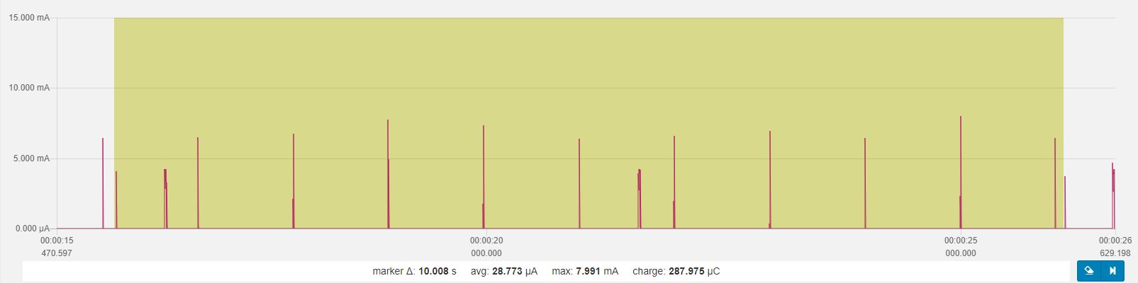 19

47 cycle 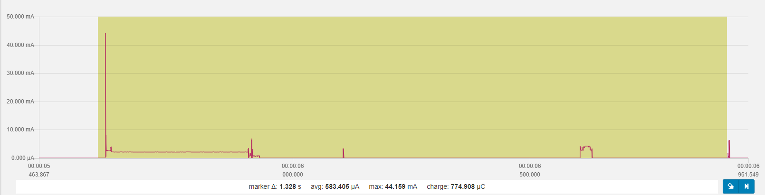 19

48 BLE 0 dBm, adv. interval 1s sensor (SHT3 and KX022) interval 5s SAADC (battery level) interval 10s overall power consumption ~30uA (28,77uA) idle power consumption 3,5uA 19

49 Part 3 – Use RTC INT for while waiting for accel data 19

50 Baseline 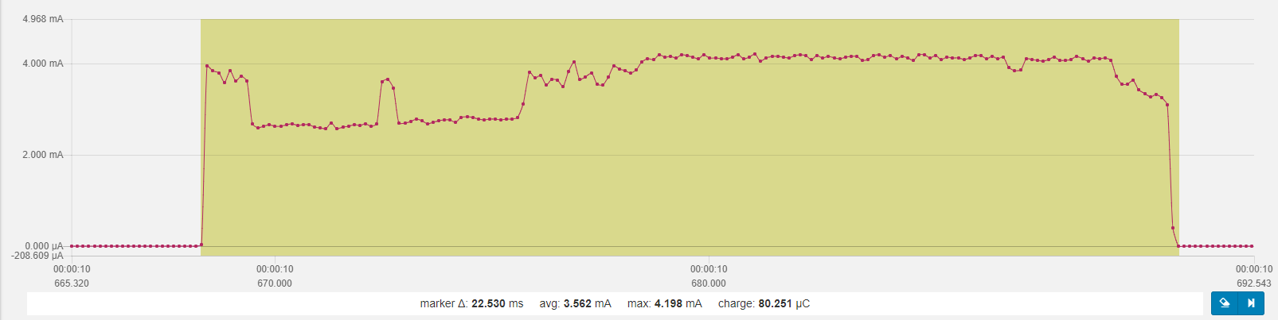 19

51 Use RTC counter (freq 1/256) for KX022 “put to operation”, “wait for accel data”, and during SHT3 temp/hum measurement (w/max. 15ms time) 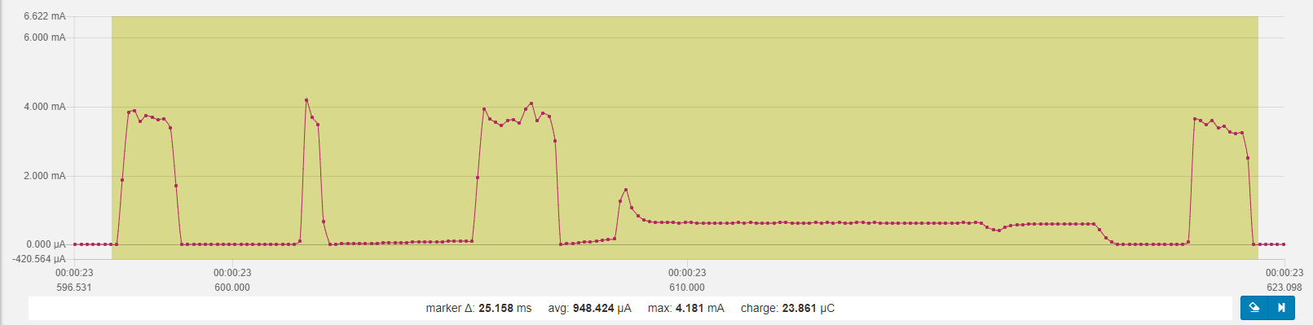 20

51.1 20

52 one minute, analog to Part 2 overall 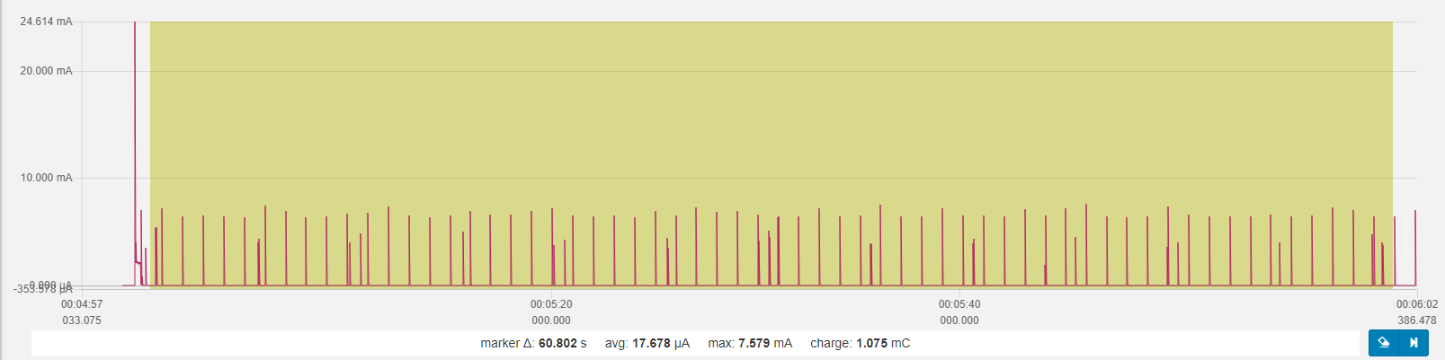 20

53 Optimization summary (Part 3 🡪 Part 4) BLE 0 dBm, adv. interval 1s sensor (SHT3 and KX022) interval 5s SAADC (battery level) interval 10s overall power consumption ~30uA (28,77uA) 🡪 17,68uA idle power consumption 3,5uA 🡪 3,5 uA 20

54 Part 4 – Further optimization 20

**55** Using nested approach: start long running SHT3 first, complete KX022 tasks and read SHT3 values **KX022: ODR 1600 -> delay time 3ms** 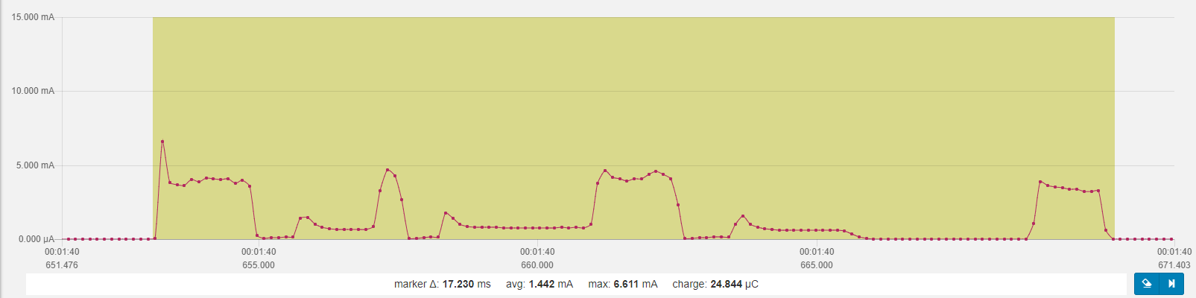 21

56 one minute, analog to Part 3 overall 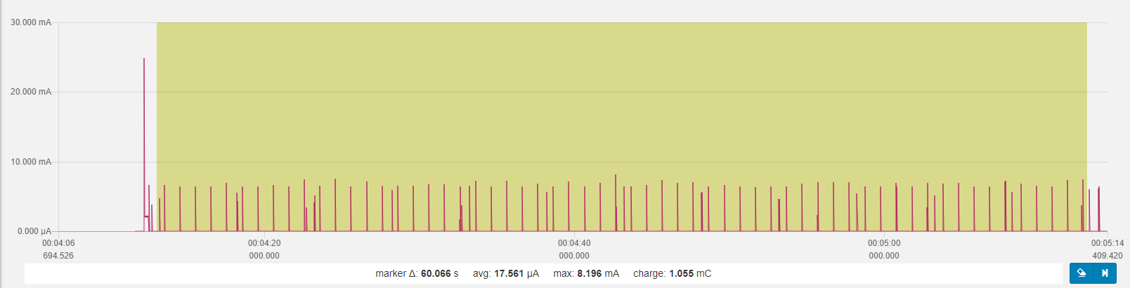 21

57 thus, no real further improvement 21

58 KX022: ODR 200 -> delay time 7ms 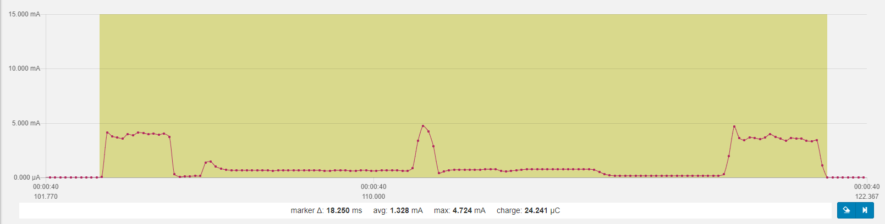 21

59 one minute, analog to Part 3 overall 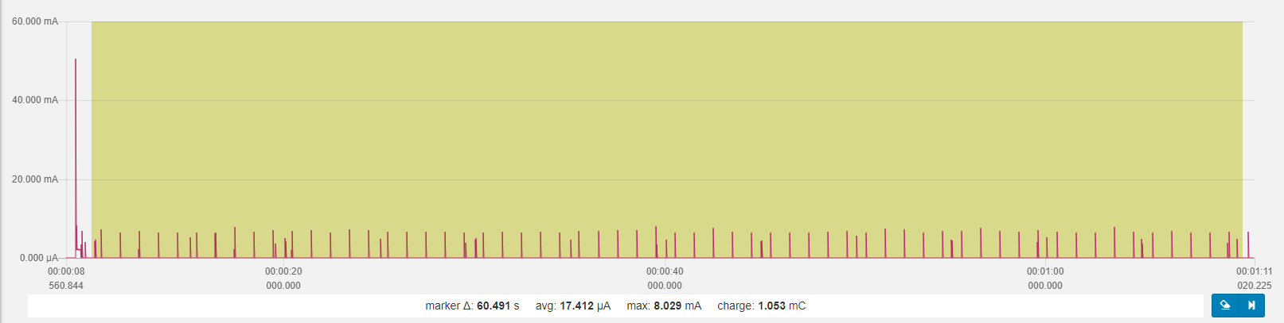 22

60 thus, no real further improvement 22

62 Longer intervals between adv and samples 23

63 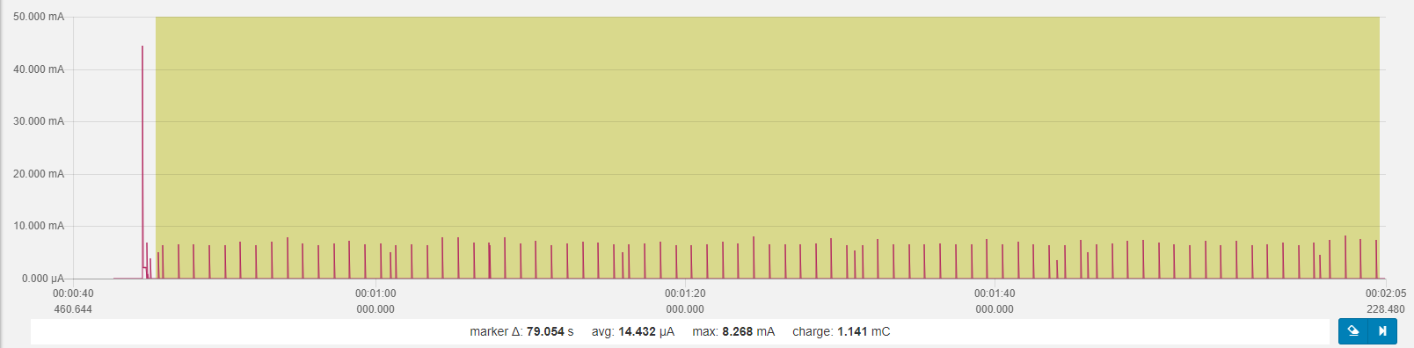BLE 0 dBm, adv. interval 1s sensor (SHT3 and KX022) interval 15s SAADC (battery level) interval 60s overall power consumption 14,4uA idle power consumption 3,6 uA 23

64 (> 1 Jahr = 365*24h = 8760h; CR2032 = 220 mAh) 23

65 Button functionality introduced 24

66 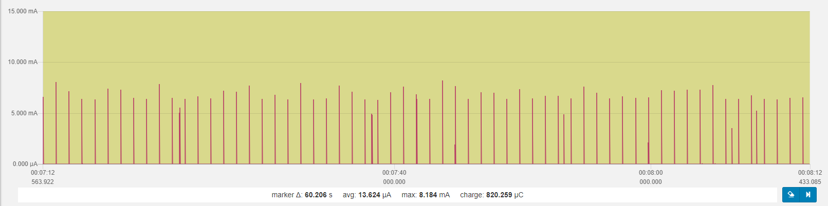 24

67 Single button press 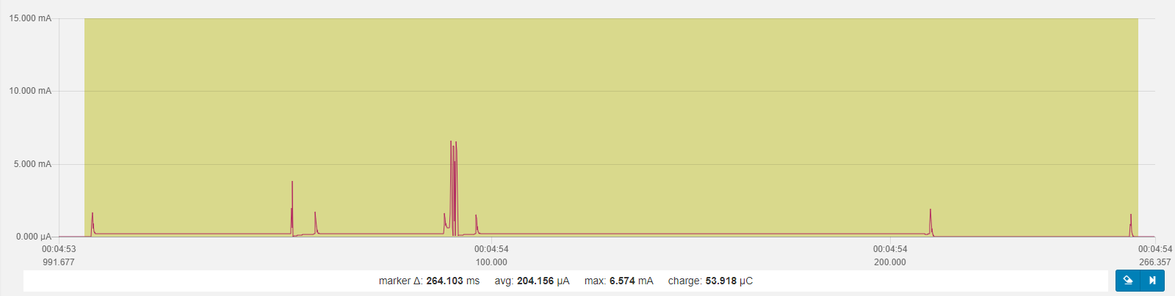 24

68 Original Beacon Firmware (for comparison) 24

69 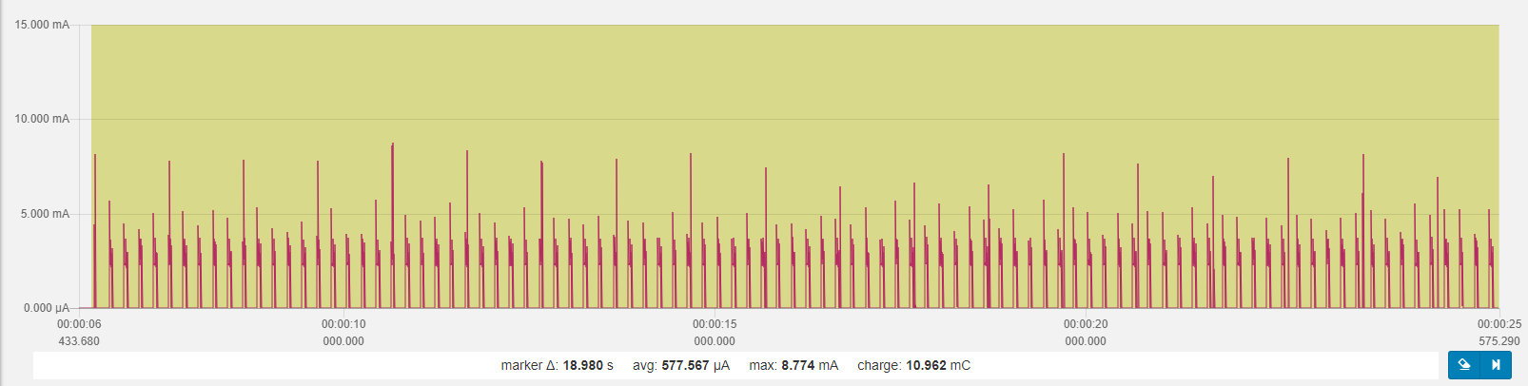 24

70 Frequent spikes (5 Hz)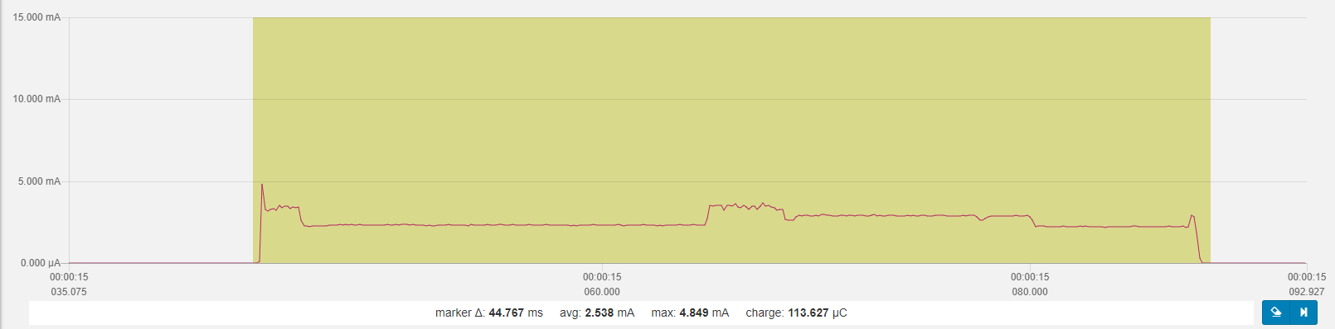 24

71 Larger but rarer spikes (1 Hz)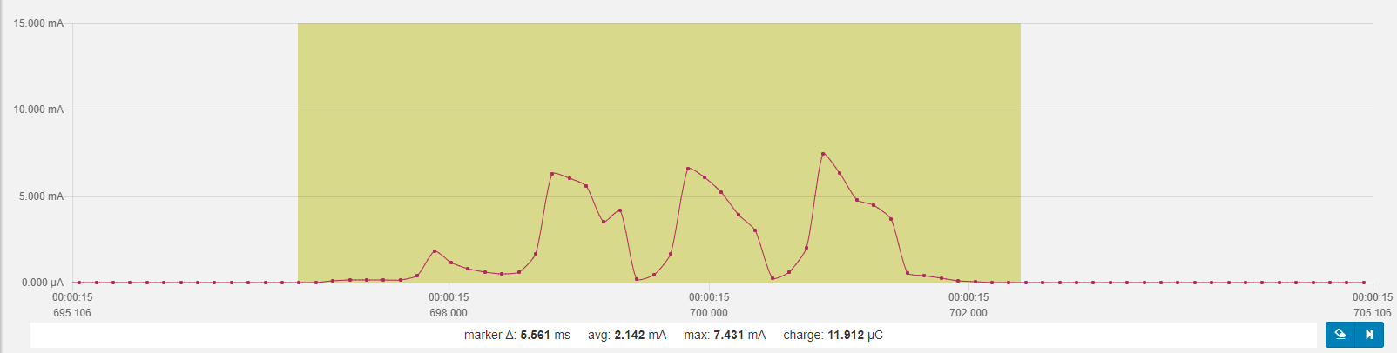 25

# Baseline

The baseline for the device is measured with only the Softdevice and no app flashed.

## According to Specification

**Nrf52 according to spec**  
TDB

**Device KX022**

high power mode 145 [uA@2.5V](mailto:uA@2.5V)

low power mode 10 uA

standby 0.9 uA

**Device SHT3**

idle state 0.2 uA (max 2 uA)

Average 2 uA while measuring w/lowest repeat.+single shot)

## Initial Measuring

### Softdevice flashed, no app flashed

### Softdevice, just go to idle mode

Figure 1 Softdevice flashed, no app flashed

# Figure 2 Softdevice, just go to idle mode

# Case 3: Softdevice, init bsp (led off), and just go to idle mode

# 

# Case 3b: as case 3 w/one led on

# 

# Case 4: as case 3 (led off) + twi_config + (both) sensor_init

# 

# Case 4a: as case 4 but no sensor_init

# 

# Case 4b: only kx022 init

# Case 4c: only SHT3 init

# Case 5: as case 4c/SHT but no KX022, no sensor data + BLE adv

# Case 6: as case 5+ SAADC measurement)

# Case 6a: as case 6 w/o BLE init/adv

# Case 7: as case 5 + SHT measurement

# Case 8: all but KX022 measurement, 1/8 data acquisition for SHT and SAADC

# Case 8a

# reduce transmit power to 0dBm from +4dBm

# adv int to 1 sec from 1/10 sec

# SHT update int to 5 sec from 1/8 sec

# SADC update int to 10 sec from 1/8 sec

# 

# Sensor update (all 5 sec)

# Adv (all 1 sec)

# Startup

# Peaks

## Power on peak

## First adv

## First sensor acquisition

# Part 2 – Power Optimization KX022 Accelerometer

# Baseline, no BLE, no sensor init

# Change to TWI without transaction manager, SHT3 init and KX022 init to standby

# With KX022 and SHT3 “one shot” measurement, 1 Hz

# One measurement

# Init KX022, Standby 1,2ms wait 1.2/ODR 3ms set to operate 0,5ms wait 1.2/ODR for value 3ms read accel values … SUM ~8ms

# Set SHT3 to SHT3_MEAS_HIGHREP_STRETCH wait clock stretch 12,5ms read temperature and humidity 2,8ms SUM ~15ms

# Process data and sleep again… Overall cycle 25ms, avg. power consumption 3,5mA, idle < 4uA

# Overall

# One 10sec cycle

# cycle

# BLE 0 dBm, adv. interval 1s sensor (SHT3 and KX022) interval 5s SAADC (battery level) interval 10s overall power consumption ~30uA (28,77uA) idle power consumption 3,5uA

# Part 3 – Use RTC INT for while waiting for accel data

# Baseline

# Use RTC counter (freq 1/256) for KX022 “put to operation”, “wait for accel data”, and during SHT3 temp/hum measurement (w/max. 15ms time)

## 

# one minute, analog to Part 2 overall

# Optimization summary (Part 3 🡪 Part 4) BLE 0 dBm, adv. interval 1s sensor (SHT3 and KX022) interval 5s SAADC (battery level) interval 10s overall power consumption ~30uA (28,77uA) 🡪 17,68uA idle power consumption 3,5uA 🡪 3,5 uA

# Part 4 – Further optimization

# Using nested approach: start long running SHT3 first, complete KX022 tasks and read SHT3 values **KX022: ODR 1600 -> delay time 3ms**

# one minute, analog to Part 3 overall

# thus, no real further improvement

# KX022: ODR 200 -> delay time 7ms

# one minute, analog to Part 3 overall

# thus, no real further improvement

# Longer intervals between adv and samples

# BLE 0 dBm, adv. interval 1s sensor (SHT3 and KX022) interval 15s SAADC (battery level) interval 60s overall power consumption 14,4uA idle power consumption 3,6 uA

#### 220mAh / 0,0144mA * 0,7 = 10.694 h = ~1.2 Jahre

# (> 1 Jahr = 365*24h = 8760h; CR2032 = 220 mAh)

# Button functionality introduced

# 

# Single button press

# Original Beacon Firmware (for comparison)

# 

# Frequent spikes (5 Hz)

# Larger but rarer spikes (1 Hz)